ScreenShot Of WebSite

**1. Index Log In Page**

**2. Log in Details page**

**3. First Question Page**

**4. Answer is Correct Page**

**5. Answer is Incorrect page**

**6. Last Question Page**

**7. Result Page**

1. **Index Page Log In**

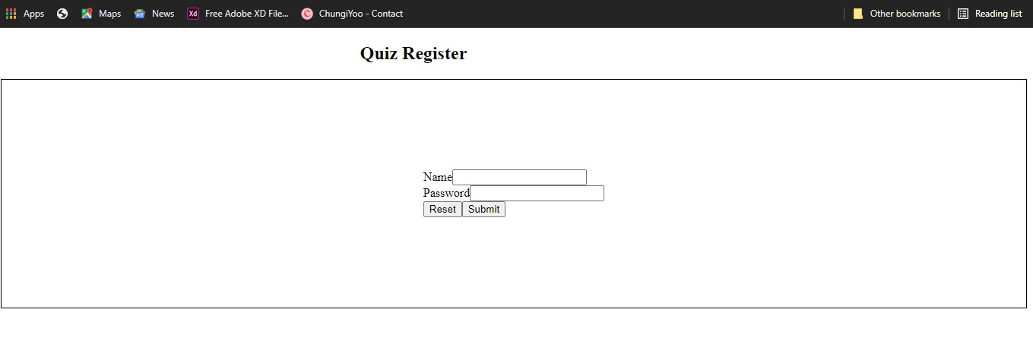

1. **Log in Details Page**

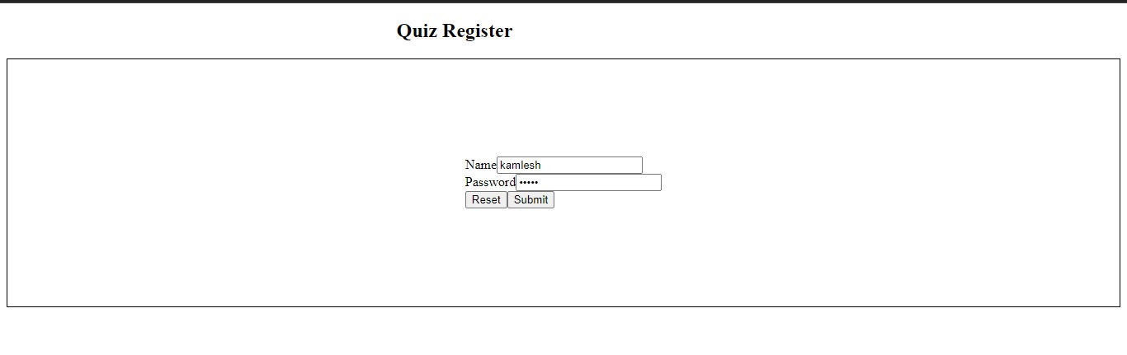

**3. First Question Page**

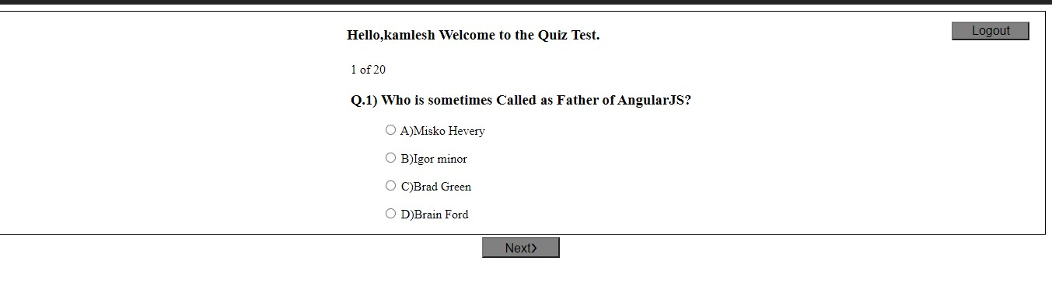

**4. Answer is Correct Page**

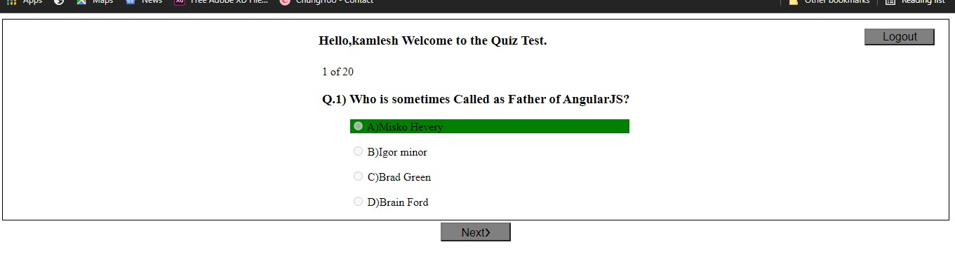

**5. Answer is Incorrect page**

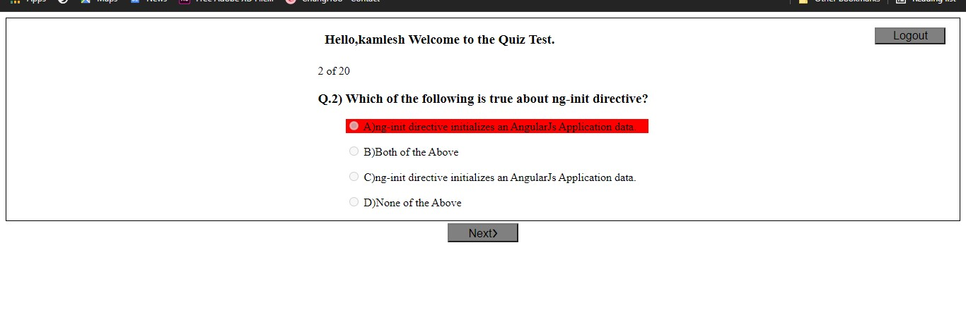

**6. Last Question Page**

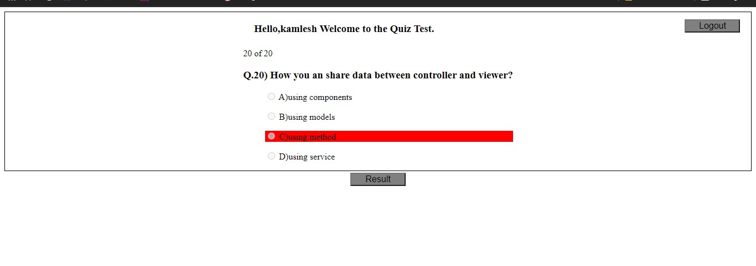**7. Result Page**

